**Training Manual:**

**How to train Tensorflow (briefly)**

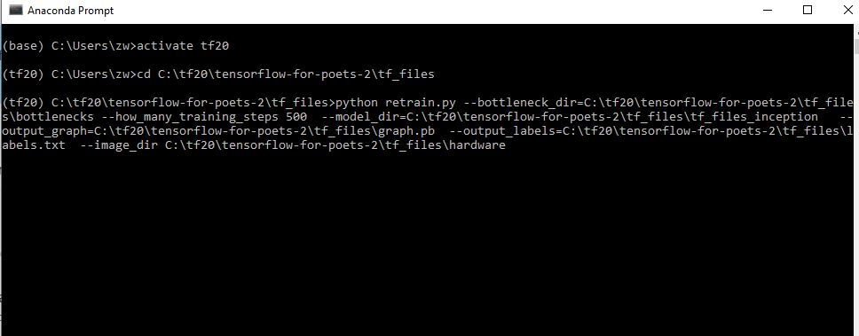

* Key in activate tf20 to run tensorflow.
* Change directory to the retrain.py folder and key in the following command to run tensorflow training script.

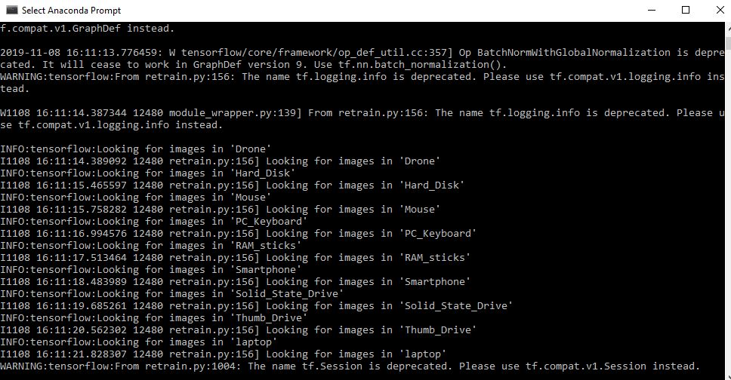

* After running the python script, the program will look for images in the objects folder to train.

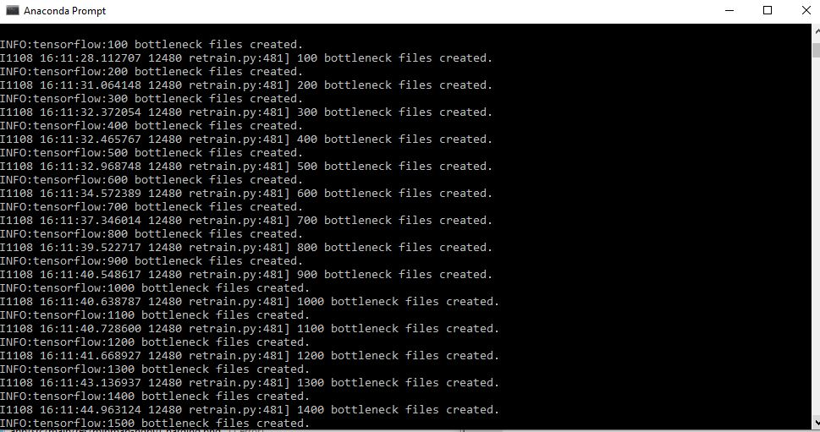

* Bottleneck also known as layer files are created.
* This will take about 30 minutes or more to complete.
* Every image is reused multiple times during training.

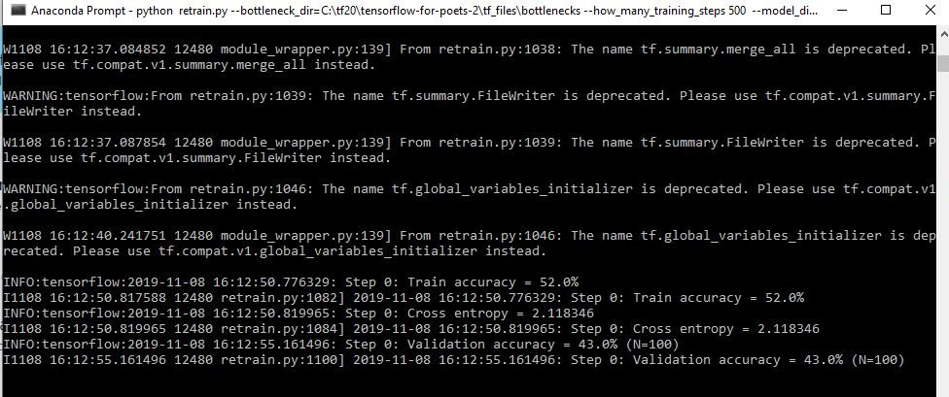

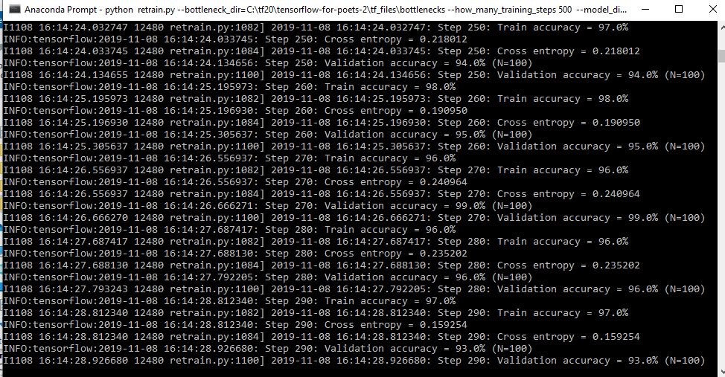

* Bottlenecks created previously will be loaded, once complete, the actual training begins.
* During the training, you will see a series of step outputs, displaying the training accuracy.
* New bottlenecks will be created after a group of images are trained.
* The more steps the program takes, the more accurate it is.

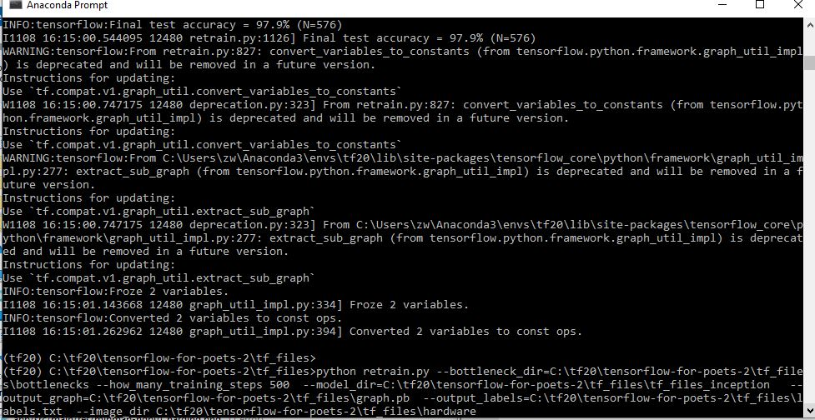

* The program is successfully trained and can be used for testing and conversion (e.g. pb to tflite or lite).

C:\Users\User\AppData\Local\Temp\7zE47CA3CB4\training8.JPG

* Files derived from the training which is used to retrain and deploy in android later.

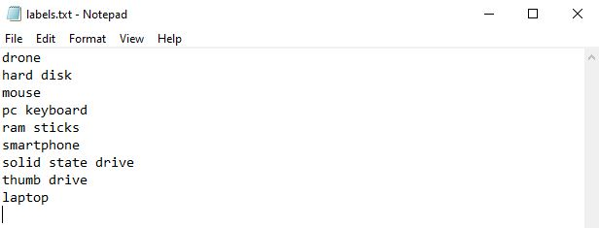

* The name of objects generated from the above training which is derived from the object folder name we have inputted at the beginning.

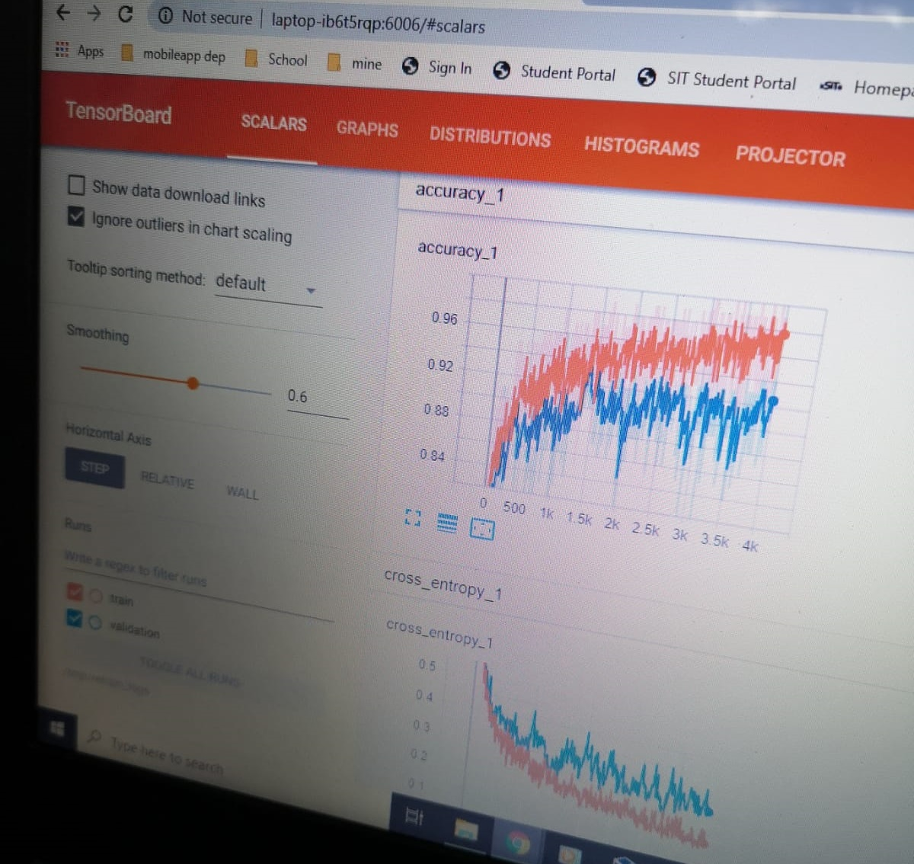

* The analysis of the training can be viewed by launching the Tensorboard.
* The graph shows that the rate of accuracy increases after each training steps and iteration over the time.